CHAPTER 5: Chemical reactions
Worksheet 5.6

Corrosion and combustion
Student: Class:

Corrosion
1. Corrosion is a process in which a metal or alloy is attacked by agents such as air and water, leading to the degradation and destruction of the material. The following diagrams compare the corrosion of iron and aluminium.
 | 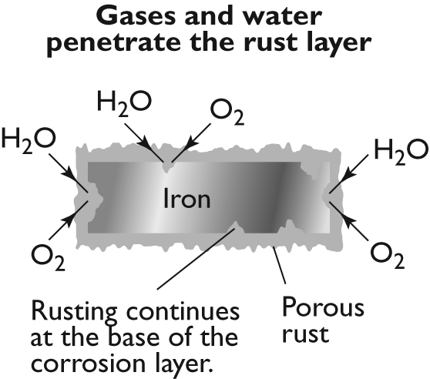 | (a) As both metals are attacked, oxide layers form on the surface. The iron oxide is called rust. Use your knowledge of the activity series of metals to predict which metal (Fe or Al) will react with air and water more rapidly.  (b) Iron continues to rust whereas aluminium stops corroding. Explain why this happens.
 | 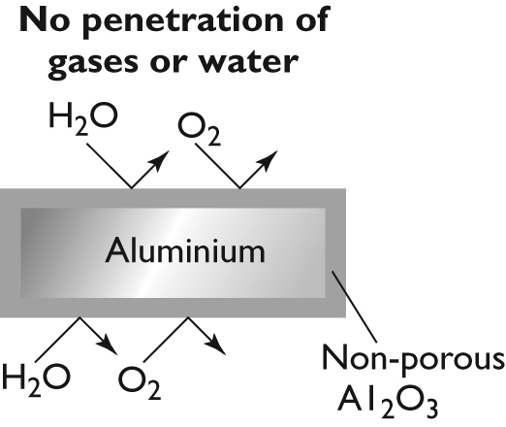
(c) Name a metal that is used to coat iron to prevent it from rusting.

Combustion
2. In combustion reactions a substance reacts with oxygen and releases energy. The energy released can be in the form of heat, light and sometimes sound. The following diagram shows the blue flame of a Bunsen burner.
 | 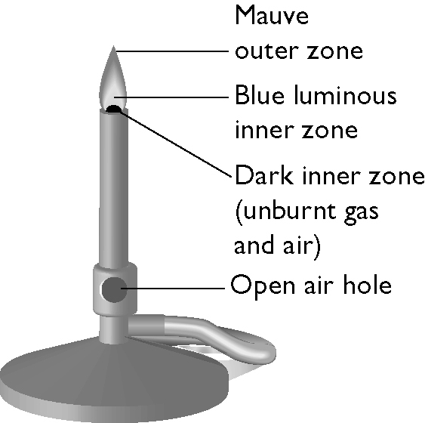 | (a) The Bunsen burner uses natural gas, which is mainly methane. Write the chemical formula for methane.  (b) The blue zone of the flame is a region of complete combustion in which the methane burns in oxygen to produce carbon dioxide and water vapour. Write a word equation and a balanced formula equation for this combustion reaction.  (c) A yellow safety flame is produced by closing the air hole. Explain why the flame turns yellow.

